Prime Factorization
# Source: AI Source: Provided by: [Data Path: Persons Table -> ID Column: 1, Name_En Column: Motasem Essam] -> From: [ChatGPT] on [7/13/2026]
Prime factorization is the process of expressing a composite number as the product of its prime factors. The result is unique (except for the order of the factors), making prime factorization one of the most important concepts in elementary number theory.
Prime factorization is based on the Fundamental Theorem of Arithmetic, which states that every integer greater than 1 is either a prime number or can be written as a unique product of prime numbers.

Definition
# Source: AI Source: Provided by: [Data Path: Persons Table -> ID Column: 1, Name_En Column: Motasem Essam] -> From: [ChatGPT] on [7/13/2026]
The prime factorization of a positive integer $n>1$is the expression of $n$as a product of prime numbers.
Mathematically,
$$n=p_{1}×p_{2}×p_{3}×⋯×p_{k}$$
where:
- $n$is the given positive integer.
- $p_{1},p_{2},…,p_{k}$are prime numbers.
Repeated prime factors are commonly written using exponents:
$$n=p_{1}^{a_{1}}p_{2}^{a_{2}}⋯p_{m}^{a_{m}}$$
where:
- $p_{1},p_{2},…,p_{m}$are distinct prime numbers.
- $a_{1},a_{2},…,a_{m}$are positive integers representing the exponents.

Rules for Prime Factorization

1. Every Composite Number Has a Prime Factorization
# Source: AI Source: Provided by: [Data Path: Persons Table -> ID Column: 1, Name_En Column: Motasem Essam] -> From: [ChatGPT] on [7/13/2026]
Every composite number can be written as a product of prime numbers.
Example
$$12=2×2×3$$
or
$$12=2^{2}×3$$

2. Prime Numbers Are Their Own Prime Factorization
# Source: AI Source: Provided by: [Data Path: Persons Table -> ID Column: 1, Name_En Column: Motasem Essam] -> From: [ChatGPT] on [7/13/2026]
A prime number cannot be broken into smaller prime factors.
Example
$$17=17$$

3. The Prime Factorization Is Unique
# Source: AI Source: Provided by: [Data Path: Persons Table -> ID Column: 1, Name_En Column: Motasem Essam] -> From: [ChatGPT] on [7/13/2026]
Ignoring the order of the factors, every integer greater than 1 has exactly one prime factorization.
Example
$$60=2×2×3×5$$
and
$$60=3×2×5×2$$
represent the same prime factorization.

4. Only Prime Numbers May Appear as Factors
# Source: AI Source: Provided by: [Data Path: Persons Table -> ID Column: 1, Name_En Column: Motasem Essam] -> From: [ChatGPT] on [7/13/2026]
Composite numbers must be broken down until every remaining factor is prime.
Example
Incorrect:
$$24=4×6$$
Correct:
$$24=2×2×2×3$$

5. Repeated Prime Factors Can Be Written Using Exponents
# Source: AI Source: Provided by: [Data Path: Persons Table -> ID Column: 1, Name_En Column: Motasem Essam] -> From: [ChatGPT] on [7/13/2026]
Repeated multiplication of the same prime is written with exponents.
Example
$$72=2×2×2×3×3 \\ 72=2^{3}×3^{2}$$

6. The Number 1 Has No Prime Factorization
# Source: AI Source: Provided by: [Data Path: Persons Table -> ID Column: 1, Name_En Column: Motasem Essam] -> From: [ChatGPT] on [7/13/2026]
Since
$$1$$
is neither prime nor composite, it has no prime factorization.
Example
$$1$$
has no prime factorization.

7. Prime Factorization Is Used to Find the GCD and LCM
# Source: AI Source: Provided by: [Data Path: Persons Table -> ID Column: 1, Name_En Column: Motasem Essam] -> From: [ChatGPT] on [7/13/2026]
Prime factorizations simplify the computation of common divisors and common multiples.
Example
$$24=2^{3}×3 \\ 36=2^{2}×3^{2}$$
Using these factorizations:
$$GCD⁡(24,36)=2^{2}×3=12 \\ LCM⁡(24,36)=2^{3}×3^{2}=72$$

Examples
# Source: AI Source: Provided by: [Data Path: Persons Table -> ID Column: 1, Name_En Column: Motasem Essam] -> From: [ChatGPT] on [7/13/2026]
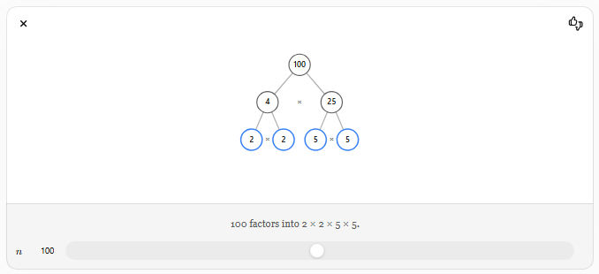
Example 1
Find the prime factorization of
$$18 \\ 18=2×9 \\ 9=3×3$$
Therefore,
$$18=2×3^{2}$$

Example 2
Find the prime factorization of
$$48 \\ 48=2×24 \\ 24=2×12 \\ 12=2×6 \\ 6=2×3$$
Therefore,
$$48=2^{4}×3$$

Example 3
Find the prime factorization of
$$100 \\ 100=2×50 \\ 50=2×25 \\ 25=5×5$$
Therefore,
$$100=2^{2}×5^{2}$$

Example 4
Find the prime factorization of
$$84 \\ 84=2×42 \\ 42=2×21 \\ 21=3×7$$
Therefore,
$$84=2^{2}×3×7$$

Example 5
Find the prime factorization of
$$150 \\ 150=2×75 \\ 75=3×25 \\ 25=5×5$$
Therefore,
$$150=2×3×5^{2}$$

Example 6
Find the prime factorization of
$$210 \\ 210=2×105 \\ 105=3×35 \\ 35=5×7$$
Therefore,
$$210=2×3×5×7$$

Methods of Prime Factorization

1. Factor Tree Method
# Source: AI Source: Provided by: [Data Path: Persons Table -> ID Column: 1, Name_En Column: Motasem Essam] -> From: [ChatGPT] on [7/13/2026]
Repeatedly split the number into factors until every branch ends with a prime number.
Example
$$36 \\ 36=6×6 \\ 6=2×3$$
Therefore,
$$36=2^{2}×3^{2}$$

2. Division Method
# Source: AI Source: Provided by: [Data Path: Persons Table -> ID Column: 1, Name_En Column: Motasem Essam] -> From: [ChatGPT] on [7/13/2026]
Repeatedly divide the number by the smallest possible prime number.
Example
Prime factorize
$$60 \\ 60÷2=30 \\ 30÷2=15 \\ 15÷3=5 \\ 5÷5=1$$
Therefore,
$$60=2^{2}×3×5$$

Real-Life Applications
# Source: AI Source: Provided by: [Data Path: Persons Table -> ID Column: 1, Name_En Column: Motasem Essam] -> From: [ChatGPT] on [7/13/2026]
Prime factorization is used in:
- Cryptography
- Cybersecurity
- Computer science
- Finding the GCD
- Finding the LCM
- Simplifying fractions
- Algebra
- Engineering
- Mathematical modeling
- Number theory

Real-Life Examples
# Source: AI Source: Provided by: [Data Path: Persons Table -> ID Column: 1, Name_En Column: Motasem Essam] -> From: [ChatGPT] on [7/13/2026]
1. Simplifying Fractions
Prime factorization helps simplify fractions by identifying common prime factors.

2. Finding the GCD
The GCD of two numbers is found using their common prime factors.

3. Finding the LCM
The LCM is obtained by combining the highest powers of all prime factors.

4. Cryptography
Modern encryption algorithms, such as RSA, rely on properties of prime factorization.

5. Computer Programming
Algorithms use prime factorization in optimization, hashing, and number-theoretic computations.

6. Engineering
Prime factorization helps determine equal groupings, repeating cycles, and measurement intervals.

Common Mistakes
# Source: AI Source: Provided by: [Data Path: Persons Table -> ID Column: 1, Name_En Column: Motasem Essam] -> From: [ChatGPT] on [7/13/2026]
- Stopping before all factors are prime.
- Forgetting repeated prime factors.
- Including 1 as a prime factor.
- Writing composite numbers in the final factorization.
- Ignoring exponent notation for repeated factors.

Key Points
# Source: AI Source: Provided by: [Data Path: Persons Table -> ID Column: 1, Name_En Column: Motasem Essam] -> From: [ChatGPT] on [7/13/2026]
- Prime factorization expresses a composite number as a product of prime numbers.
- Every composite number has one unique prime factorization (ignoring order).
- Prime numbers are already completely factorized.
- The number 1 has no prime factorization.
- Prime factorization is essential for finding the GCD, LCM, and simplifying fractions.

Prime Numbers vs. Prime Factorization
# Source: AI Source: Provided by: [Data Path: Persons Table -> ID Column: 1, Name_En Column: Motasem Essam] -> From: [ChatGPT] on [7/13/2026]
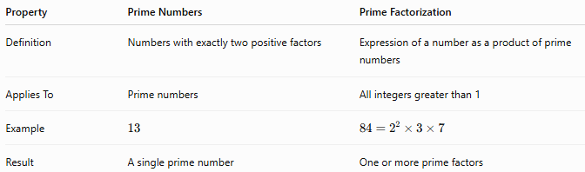
Property | Prime Numbers | Prime Factorization
Definition | Numbers with exactly two positive factors | Expression of a number as a product of prime numbers
Applies To | Prime numbers | All integers greater than 1
Example | $$13$$ | $$84=2^{2}×3×7$$
Result | A single prime number | One or more prime factors

Conclusion
# Source: AI Source: Provided by: [Data Path: Persons Table -> ID Column: 1, Name_En Column: Motasem Essam] -> From: [ChatGPT] on [7/13/2026]
Prime factorization is the process of expressing a composite number as a product of prime numbers. According to the Fundamental Theorem of Arithmetic, every integer greater than 1 has a unique prime factorization (up to the order of the factors). Prime factorization is a cornerstone of elementary number theory and is widely used in divisibility, the GCD, the LCM, fraction simplification, cryptography, computer science, engineering, and many other areas of mathematics.

